**Cupping in basal facet investigation, 8/1/23**

Tia’s notes

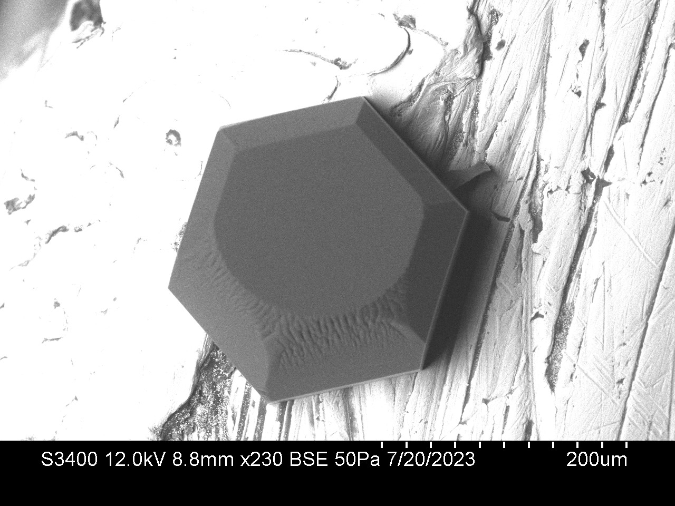

We noticed that the basal surface of this crystal appears to have an inward cupping to it, curving down towards the center and upwards at the ends. The image above is of detector A, for case 3.0 found in GitHub/ice2021/crystals/2023-07-20/50pa/case3.

We characterized this surface in the folder case3.0 (calibration) under the same directory.

To get a sense for the extent of the cupping, we created an .stl file, which can be found in case3.0 (calibraiton) as Segments1_retrievedwskirt.stl. <https://www.viewstl.com/> is a good platform to view this on, and in the screenshot below you can see the slight curvature. This is created with segments defined by 40x40 pixel boxes on the surface as shown.

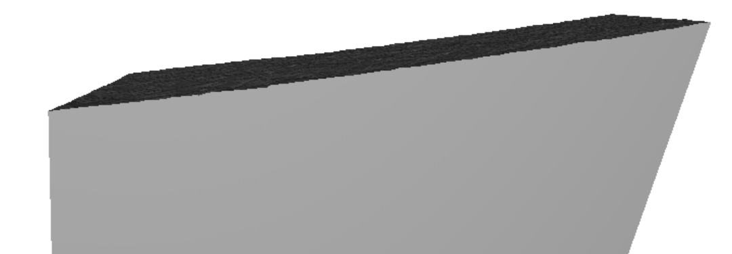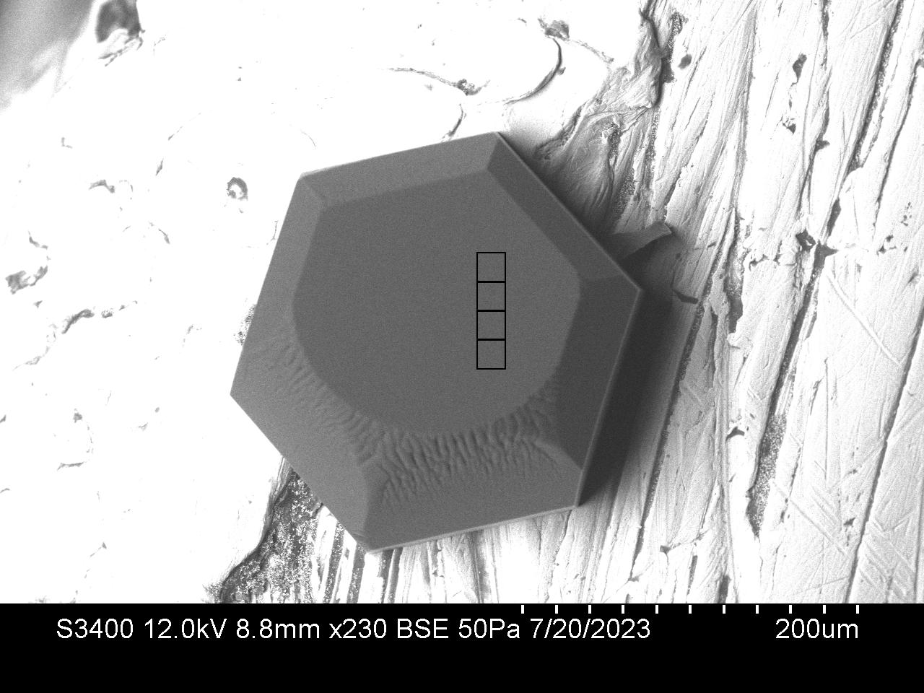

From the image text file, we found that the pixel size is 0.43 um, meaning 4 segments each 40 pixels in length is about 69 um, or 69000nm = l. Using the measure tool in Image J, after calibrating to the length of the segments (l) we measured that the depth down from straight across (d) was about 430nm. This corresponds to a depth of about 1400 layers over 35um, given that each layer is 0.3nm. This raises the need for further exploration, as the model is currently operates with a depth of many fewer layers, reaching steady state sooner.

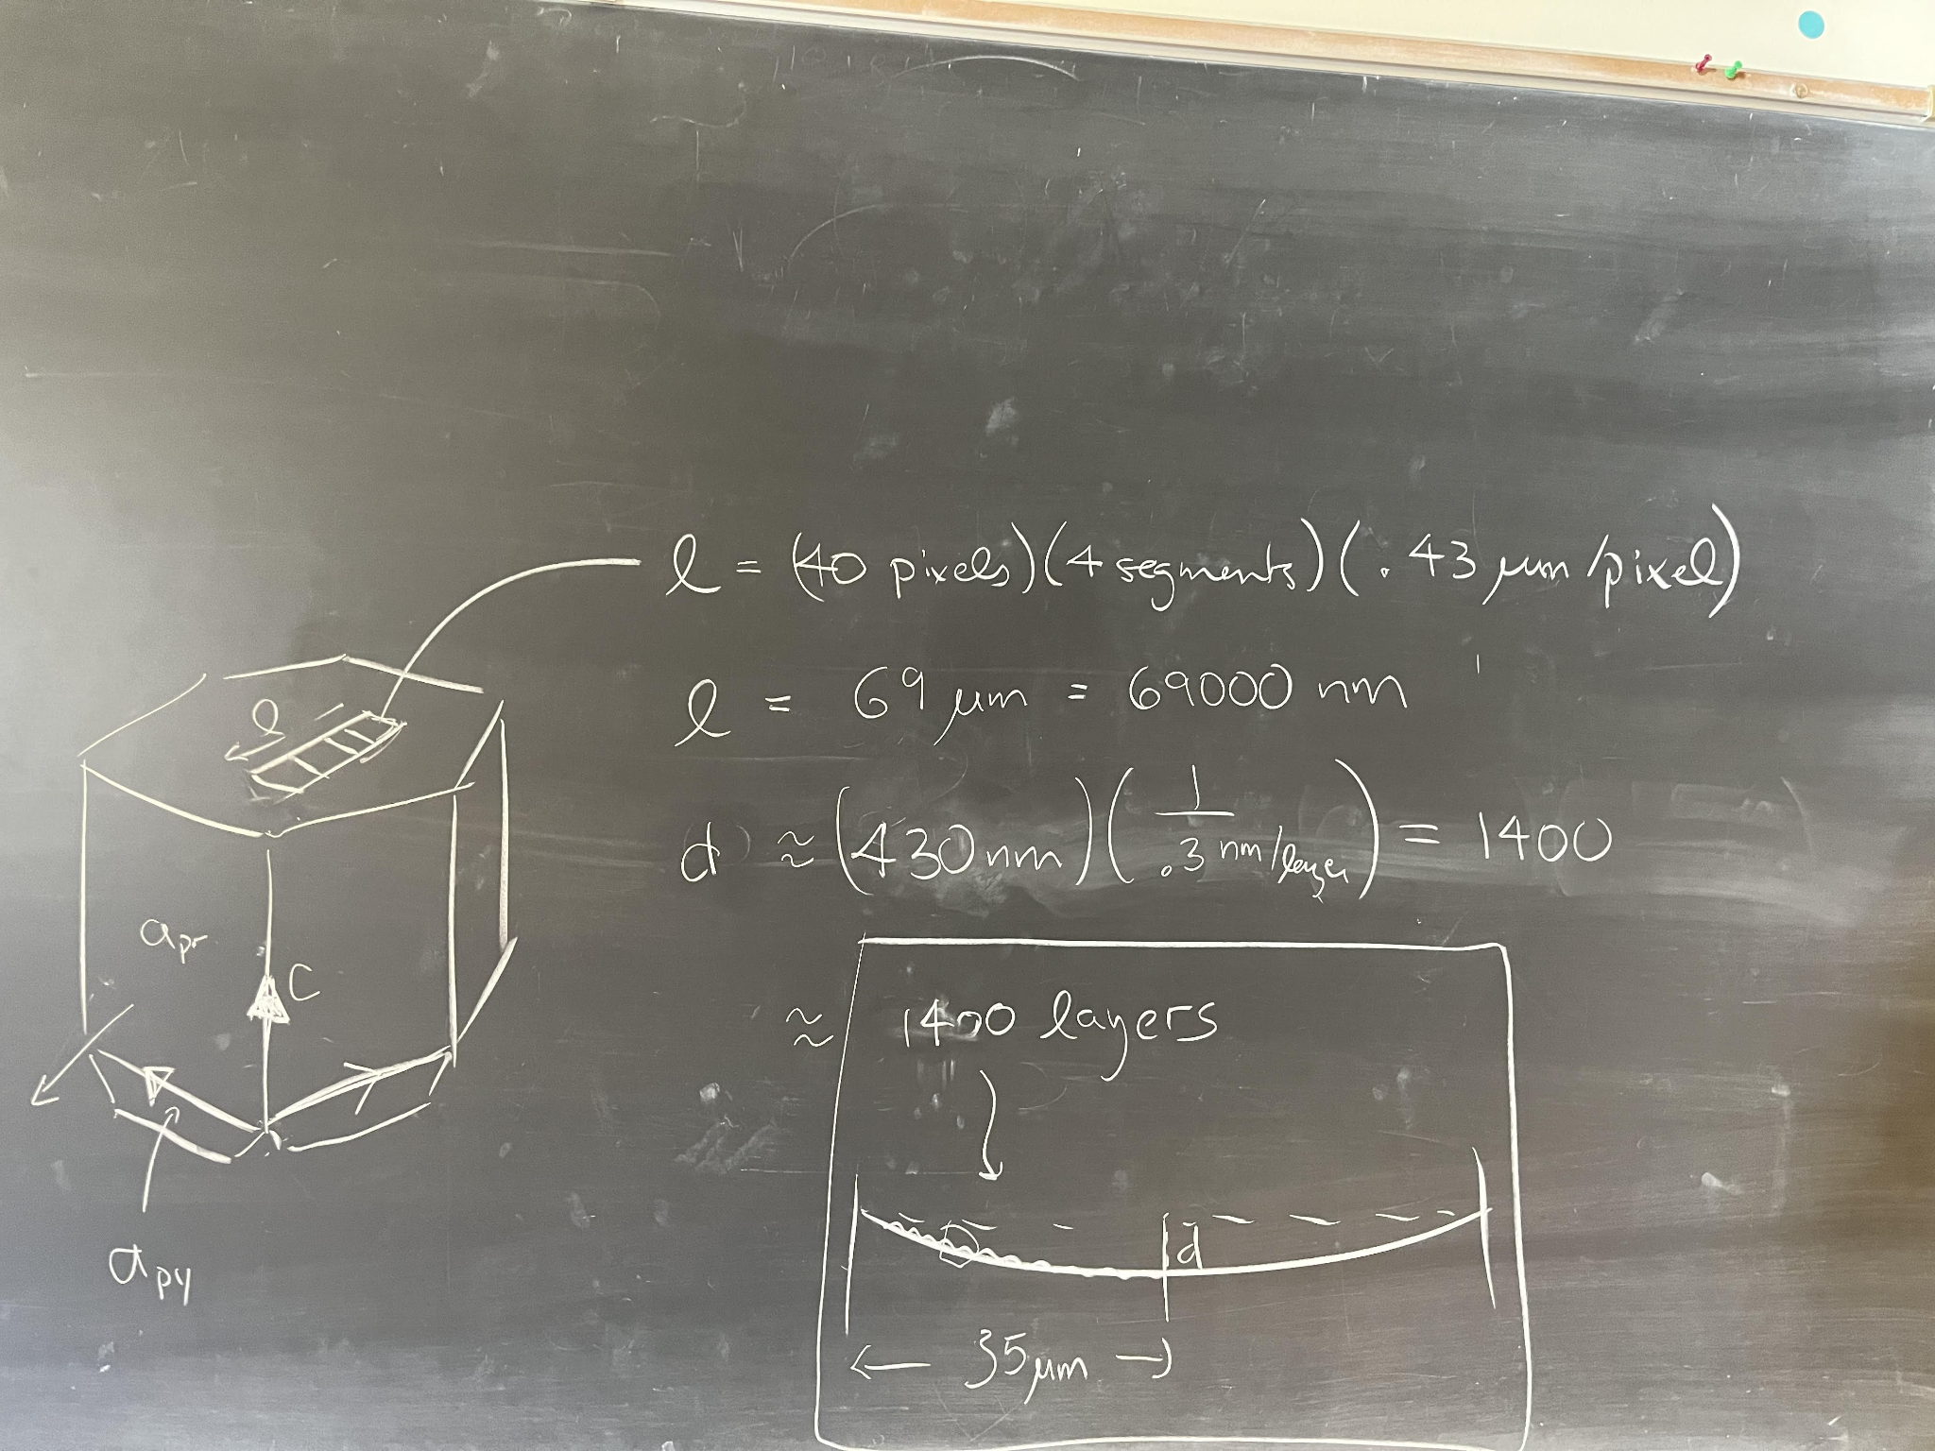

Even with Fourier, can’t resolve something that takes thousands of steps. Certainly too big to do in 2 dimensions. Maybe the height is not the right variable to simulate? Some way to develop ordinary diff eq where just number of steps is variable, and it resolves according to conditions. Reduce from an ODE to a PDE, run numerical experiments. Variable of interest could be step density over a grid (steps/unit)? Is it spatially varying?